MB 360 Lab Workbook
  - MB 360: Scientific Inquiry in Microbiology At the Bench| Microbial Metabolism and Genomics
Carlos C. Goller, Ph.D.
Camila Loyola, Graduate Teaching Assistant
2026-04-17
Table of contents

MB 360 ELN Workbook
This Quarto book reorganizes the MB 360 schedule and ELN outline into eight modules that follow the flow of the course from basic lab technique to final project design.

How To Use This Book
Each module is structured as a working lab-book chapter with the same core parts:
- purpose and learning outcomes
- skills and knowledge
- task and criteria for success
- background and procedures
- results, analysis, and discussion prompts

Module Sequence
- Getting Started: Lab safety, pipetting, and serial dilutions
- Microbial Propagation: Plate streaking and liquid cultures
- Microbial Growth Curves: Strain comparisons and biofilms
- Microbial Metabolism: Biolog GEN III characterization
- Microbial Interactions: Isolate co-culture
- Microbial Genome Sequencing: DNA isolation, quantification, and sequencing
- Data Analysis and Experimental Design: Assembly, annotation, and interpretation
- Share Your Results: Final experiment planning, execution, and reflection

Notes
The chapters preserve the structure of the source outline while adapting it to a cleaner Quarto book format. Module 8 remains intentionally open-ended because it is designed for student-defined experiments.

1. Module 1: Getting Started

1.1 Overview
Week 1 focuses on safe lab practice, pipetting fundamentals, and the first ELN entries for MB 360. Students review lab safety, practice using micropipettes, and document results in a way that prepares them for the rest of the course.

1.2 Purpose
The goal of this module is to prepare you to work safely and efficiently in the lab. You will review safety procedures for the teaching labs in Thomas Hall, use personal protective equipment correctly, and practice working with mechanical micropipettors and electronic multichannel pipettes.

1.3 Learning Outcomes
- List the personal protective equipment needed for MB 360.
- Identify the features of the mechanical pipettes used in the course.
- Explain how streak plating helps dilute bacteria.
- Describe the advantages of electronic and multichannel pipettes.
- Create a lab entry in the ELN system.
- Collect and interpret pipetting data.
- Create a team charter and communication plan.

1.4 Skills and Knowledge

1.4.1 Skills
- Follow basic safety precautions in a laboratory with live bacterial organisms.
- Transfer a range of liquid volumes reproducibly with pipettors.
- Document protocols, observations, and results in an ELN.
- Interpret variability in pipetting performance.

1.4.2 Knowledge
- Pipettor types and their volume ranges.
- PPE expectations for microbial work.

1.5 Task
Review the background and procedures before lab. During class, work with your lab partner to complete the pipetting activities, document all observations, and record any changes you made during the session.

1.6 Criteria for Success
Successful completion requires active participation in the in-lab activities, completion of the pipetting exercises, collection of usable data, and a complete ELN entry with results and reflection.

1.7 Background
The course uses teaching labs in Thomas Hall and focuses on work with Delftia acidovorans. Because environmental isolates may be naturally antibiotic-resistant, all work should minimize exposure and maintain good containment practices.

1.8 Procedures

1.8.1 Lab Safety
- Treat all tips as potential biohazards.
- Clean the bench before and after each session with 70% ethanol.
- Dispose of cultures and plates using the designated biohazard procedures.

1.8.2 Methods: Practice Micropipetting With the Pipette Practice Card
Figure Figure 1.1 shows the micropipette volume display students should learn to read before beginning the practice-card exercise.
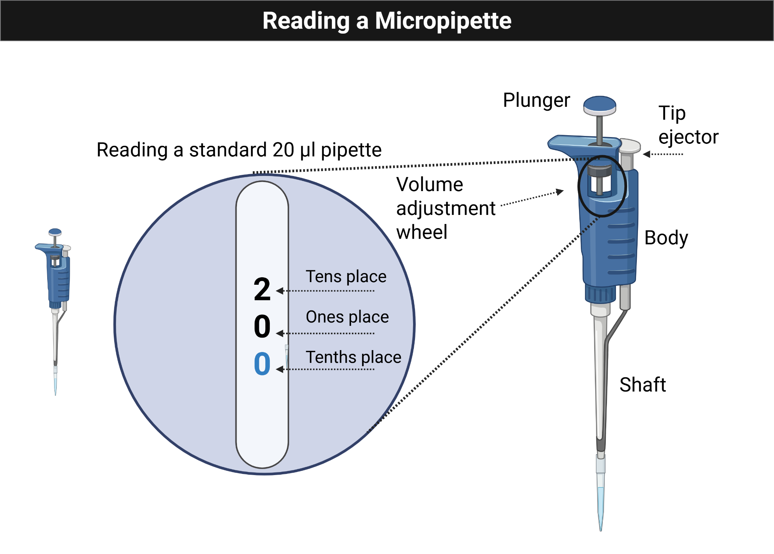
Figure 1.1: Micropipette volume display used for introductory pipetting practice.
- Add the correct amount of liquid to each circle and keep each drop within the circle.
- Have each group member try at least two different volumes.
- Practice picking up the entire drop without leaving liquid behind.
- Pipette several 5 µL drops and compare them for consistency.
- Combine four 4 µL additions into a single spot, predict the total volume, then test whether you can recover it fully.

1.8.3 Methods: Volume Challenge
Your instructor will provide blue, yellow, and red dyed water. Use the Pipette Practice Card to complete the transfer and mixing exercise.

1.8.3.1 Mixing With a Micropipette
- When adding a second liquid to a dot, press only to the first stop.
- Release slowly to draw the same volume back up.
- Repeat until the colors are mixed evenly.
- Finish by pressing to the second stop and removing the tip cleanly.

1.8.3.2 Instructions
- Add 13.5 µL of blue dye to dot A.
- Add 17.5 µL of yellow dye to dot C.
- Add 17 µL of red dye to dot E.
- Transfer 2 µL from dot A to dot F.
- Transfer 4.5 µL from dot C to dot B.
- Transfer 3 µL from dot E to dot D.
- Calculate the volume now present on each dot.
- Mix 6 µL from dot E into dot F.
- Mix 3.5 µL from dot A into dot B.
- Mix 5 µL from dot C into dot D.

1.8.4 Protocol Notes
Record any mistakes, deviations, or adjustments made during the experiment.

1.9 Results
Paste a picture of the completed card and annotate it, or add written notes describing your observations.

1.10 Result Analysis
Explain what the results show, whether the liquid transfers matched expectations, and what they suggest about your current pipetting precision.

1.11 Discussion Questions
- Did you make bubbles while mixing? What caused them?
- Was any liquid left on the card or was there air space in the pipette tip after transfer?
- Based on your results, how would you rate your pipetting skill?

1.12 Serial Dilutions

1.12.1 Purpose
Practice accurate small-volume pipetting while learning how serial dilutions work.

1.12.2 Background
Serial dilution is the stepwise dilution of a solution by a constant factor. In this module, you will perform a 1:10 serial dilution of crystal violet in a 96-well plate to connect pipetting technique with quantitative analysis.
Figure Figure 1.2 summarizes the repeated transfer logic behind the serial dilution workflow.
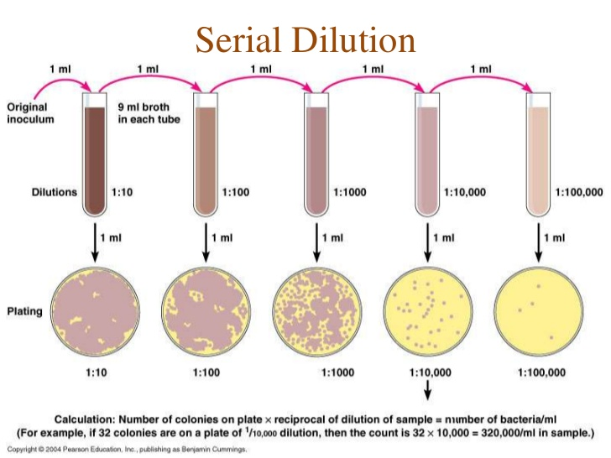
Figure 1.2: Serial dilution overview showing stepwise dilution from a concentrated starting sample.

1.12.3 Protocol
Use Figure Figure 1.3 to plan the first rows of the microplate before starting the transfers.
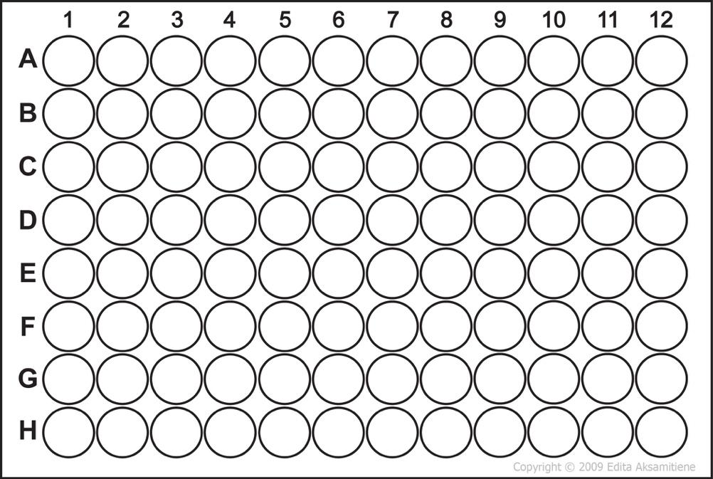
Figure 1.3: Top rows of a 96-well microplate used to plan the serial dilution setup.
- Add 50 µL of water to each well in row A.
- Add 50 µL of crystal violet to well A1.
- Mix A1 gently, then transfer 50 µL from A1 to A2.
- Repeat across row A through A12.
- Discard the final 50 µL after mixing A12.
- Repeat the same process for rows B, C, and D as assigned between partners.
- Add 100 µL of water to well H12 as a negative control.
- Compare rows visually, then measure absorbance with the plate reader.

1.12.4 Planning Prompts
Figure Figure 1.4 can be copied into the ELN or notebook to sketch the intended arrangement of controls and dilutions.
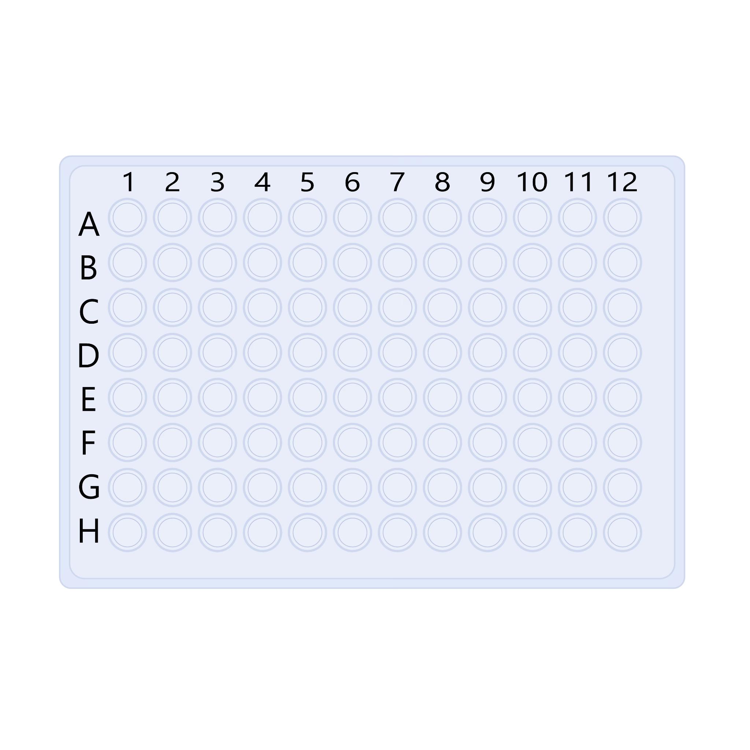
Figure 1.4: Blank 96-well plate template for planning and annotation.

 Important
Note that you will need to respond to the questions below as part of your ELN entry, so consider them as you plan your workflow.

- Where does the water go?
- How much water is added to each well?
- Where is crystal violet added first?
- What transfer step is repeated each time?
- What should happen after mixing well A12?

1.12.5 Reflection Prompts
 Note
Note that each module will have a set of reflection questions to help you connect the activities to the learning outcomes. You will need to answer these questions in your ELN entry, so consider them as you work through the activity.

- What is the dilution factor in this series?
- How dilute is the final sample relative to the starting dye?
- Did the visual pattern match your prediction?
- Did the plate reader data match your qualitative observations?

2. Module 2: Microbial Propagation

2.1 Overview
Weeks 2 and 3 focus on plate streaking, colony observation, and starting liquid cultures for later growth analysis.

2.2 Purpose
- Recover and propagate Delftia acidovorans from colonies.
- Observe colony morphology, streak plates, and start liquid cultures.
- Review safety procedures for working with live microbial isolates.

2.3 Learning Outcomes
- List the items needed to propagate microbes in liquid cultures and 96-well plates.
- Explain the stages of bacterial growth on a growth-curve graph.
- Describe defined, complex, selective, enriched, and differential media.
- Discuss the importance of controls.
- Practice inoculating and diluting liquid cultures.
- Describe the purpose, methods, and preliminary results of microbial growth experiments.
- Collect and interpret colony morphology and growth data.
- Create and use a team data management plan.

2.4 Skills and Knowledge

2.4.1 Skills
- Work safely with bacterial growth on agar plates.
- Document protocols and results clearly.
- Interpret colony morphology and growth in liquid TSB medium.
- Propagate bacteria in liquid culture.

2.4.2 Knowledge
- PPE for microbial work.
- Loop use, sterilization, and streaking methods.
- Propagation of microorganisms in solid and liquid media.

2.5 Task
Review the protocol before lab and work with your partner to complete the propagation tasks, document observations, and record changes to the procedure.

2.6 Criteria for Success
You should complete the solid- and liquid-media propagation tasks, collect observations that can be analyzed, and submit a complete ELN entry.

2.7 Background
This module uses Delftia acidovorans and related environmental isolates. Each group works with one isolate and is responsible for careful handling, observation, and documentation.

2.8 Procedures

2.8.1 Lab Safety

2.8.1.1 Before Lab
 Caution
Note that we will be working with live microbial isolates today. Please follow all safety protocols and dispose of potentially biohazardous materials properly.

- Wear a lab coat, goggles, and gloves.
- Wipe the bench and pipettors with 70% ethanol.

2.8.1.2 During Lab
- Treat all tips as potential biohazards.
- Remove PPE when leaving the lab.
- Discard samples and disposables in the correct containers.
- Keep personal item use to a minimum.

2.8.1.3 After Lab
- Wipe the station with 70% ethanol.
- Decontaminate any personal items touched during lab.
- Dispose of gloves in the main biohazard container.

2.8.2 Methods: Observe Colony Morphology
- Obtain a TSA plate containing colonies of your isolate.
- Observe colony appearance without opening the plate.
- Record size, shape, and any additional visible features.
- Photograph the plate using the provided black background.
- Share the photos with all team members.

2.8.3 Methods: Plate Streaking
Figure Figure 2.1 illustrates the transfer of a single colony to a fresh plate during the streaking workflow.
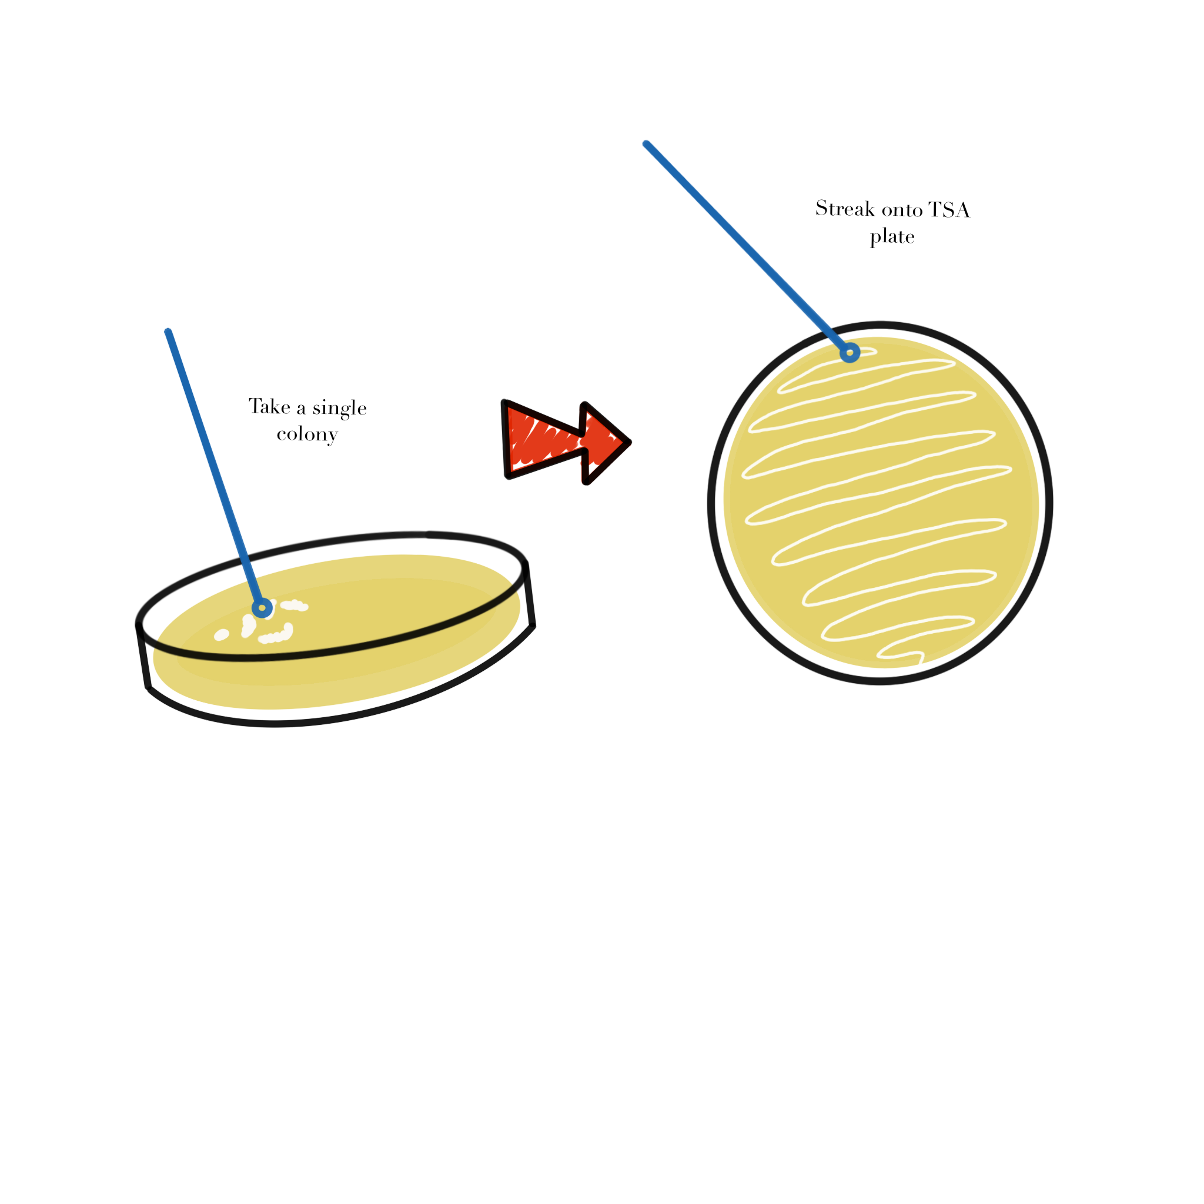
Figure 2.1: Single-colony transfer onto a fresh TSA plate for streaking practice.
- Use a sterile loop to pick a single colony.
- Open the plate as little as possible.
- Streak onto a fresh TSA plate.
- Label the plate with your name, class, and date on the bottom edge.

2.8.4 Methods: Starting a Liquid Culture
- Obtain TSB and sterile culture tubes.
- Label tubes for the TSB control, your isolate, and Delftia acidovorans SPH-1.
- Transfer a colony into the labeled tube without touching the loop to any other surface.
- Cap each tube correctly and place them in a shaking incubator at 30 C.
- Incubate for 24 hours.

2.8.5 Protocol Notes
Record any mistakes, deviations, or isolate-specific observations.

2.9 Results
Add a photo of the plate and notes describing what you observed.

2.10 Result Analysis
Explain whether the observed colony features and culture setup matched expectations.

2.11 Discussion Questions
- If a student touched the agar with a thumb and unexpected colonies appeared later, what was the likely source of contamination and how could it have been prevented?
- What differences would you predict between static and shaking liquid growth?

3. Module 3: Microbial Growth Curves

3.1 Overview
Weeks 4 and 5 focus on growth-curve experiments, multichannel pipetting, and biofilm viability assays.

3.2 Purpose
- Evaluate growth rates of different Delftia species.
- Prepare liquid cultures from single colonies for 96-well growth assays.
- Analyze growth parameters from shaking cultures.
- Investigate differences in biofilm formation among isolates.

3.3 Learning Outcomes
- List safety considerations for propagating microbes.
- Explain the differences between static and shaking growth.
- Describe the features of biofilms.
- Discuss the significance of growth curves.
- Practice using a multichannel pipette.
- Practice diluting overnight cultures and seeding 96-well plates consistently.
- Describe the purpose, methods, and preliminary results of microbial propagation experiments.
- Collect and interpret growth and biofilm data.
- Create an annotated bibliography with at least five sources.

3.4 Skills and Knowledge

3.4.1 Skills
- Work safely with liquid cultures in 96-well plates.
- Document protocols and results clearly.
- Interpret growth-curve and biofilm data.
- Propagate bacteria in liquid culture.

3.4.2 Knowledge
- PPE requirements for microbial work.
- Propagation of microorganisms in liquid media.
- Seeding 96-well plates for growth and biofilm analyses.

3.5 Task
Review the procedures before lab and work with your partner to complete the growth and biofilm assays and document all observations.

3.6 Criteria for Success
Successful completion requires participation in both assay workflows, collection of analyzable data, and a complete ELN entry.

3.7 Background
This module compares growth and biofilm formation in Delftia acidovorans, Delftia tsuruhatensis, and student isolates while maintaining strong contamination control.

3.8 Procedures

3.8.1 Lab Safety
- Wear the required PPE.
- Clean the bench and pipettors with 70% ethanol.
- Treat all tips as biohazards.
- Dispose of plates and gloves in the correct waste streams.

3.8.2 Methods: Liquid Culture Setup
- Isolated colonies were transferred to liquid medium.
- Inoculated tubes were grown overnight at 30 C with shaking at 200 to 250 RPM.

3.8.3 Methods: Growth Assay Setup
Figure Figure 3.1 provides a reusable 96-well template for mapping control wells and isolate conditions before loading the plate.
Figure 3.1: Blank 96-well plate layout for planning growth-curve wells and controls.
- Prepare 1:1000 dilutions of the overnight cultures.
- Use positive and negative controls.
- Pour diluted cultures into sterile reservoirs.
- Use a multichannel pipette to add 100 µL to the assigned 96-well plate columns.
- Seal the plate with a breathable seal.
- Load the plate into the plate reader for 48 hours at 30 C with shaking.

3.8.4 Methods: Biofilm Assay Setup
- Prepare fresh 1:1000 dilutions for the biofilm plate.
- Seed the assigned wells with 100 µL per well.
- Add the peg lid without contaminating the pegs.
- Incubate for 48 hours at 30 C.

3.8.5 Methods: Biofilm Viability
Figure Figure 3.2 outlines the wash-and-detection workflow used to measure biofilm viability after incubation.
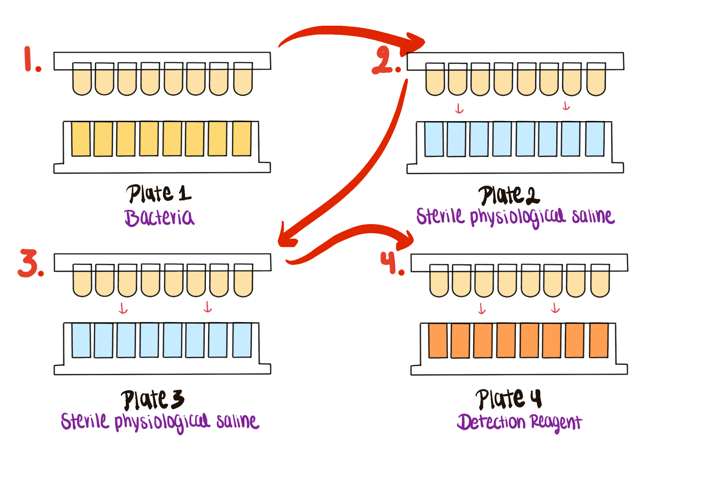
Figure 3.2: Biofilm viability workflow using wash plates and detection reagent.
- Wash the peg lid using PBS in separate plates.
- Prepare the detection reagent with WST solution, electron mediator reagent, and TSB.
- Transfer the peg lid to the reagent plate and incubate at 37 C.
- Measure absorbance at 450 nm.

3.8.6 Protocol Notes
Record any mistakes, deviations, or isolate-specific observations.

3.9 Results

3.9.1 Growth Curves
- Save and share the raw plate-reader data.
- Format the data for analysis.
- Upload the data file to the repository.
- Plot growth curves and compare isolates and wells.

3.9.2 Biofilm Viability
- Save and share the raw absorbance values.
- Subtract the average TSB-only background.
- Calculate average absorbance and standard deviation for each condition.
- Plot the background-corrected averages for comparison.

3.10 Result Analysis
Use your code and plots to explain whether the observed growth and biofilm behavior matched expectations.

3.11 Discussion Questions
- Why are biofilms difficult to eliminate, even when antibiotics are used?
- What growth-curve pattern would you expect for your isolate, and why?

4. Module 4: Microbial Metabolism

4.1 Overview
Weeks 6 and 7 focus on Biolog GEN III phenotypic characterization, growth measurements, and metabolic interpretation.

4.2 Purpose
- Evaluate and analyze bacterial growth in different environments.
- Perform metabolic profiling.
- Identify conditions that support or inhibit bacterial growth.
- Use multichannel pipettes to seed 96-well plates for growth assays.
- Apply the principles behind Biolog GEN III plates to your overall experiment.

4.3 Learning Outcomes
- List safety considerations for propagating microbes.
- Explain the purpose of GEN III Biolog plates and metabolic tests.
- Describe the features of biofilms.
- Discuss the significance of growth curves.
- Practice using a multichannel pipette.
- Use a turbidimeter to adjust inoculum turbidity.
- Seed 96-well plates consistently without contamination.
- Describe the purpose, methods, and preliminary results of GEN III phenotypic characterization experiments.
- Collect and interpret growth data from Biolog GEN III plates.
- Create a draft for the individual and group projects.
- Explain how the experiment contributes to the overall research goal.

4.4 Skills and Knowledge

4.4.1 Skills
- Follow PPE and microbial safety procedures.
- Use Biolog plates and multichannel pipettors correctly.
- Use a turbidimeter to adjust bacterial density.
- Analyze bacterial growth data from 96-well plates.

4.4.2 Knowledge
- PPE requirements for microbial work.
- Phenotypic assays and growth assessment.
- Seeding 96-well plates for bacterial growth.

4.5 Task
Review the background and procedure information before lab and work with your partner to complete the assay setup and documentation.

4.6 Criteria for Success
Complete the in-lab assay setup, collect analyzable data, and finish the ELN entry with observations and interpretation.

4.7 Background
Biolog Blood Universal Growth agar and GEN III MicroPlates make it possible to test bacterial growth across many environmental and chemical conditions at once. The plate uses metabolic dye chemistry to report growth and biochemical activity across up to 94 tests.
Figure Figure 4.1 shows the overall GEN III plate layout used to interpret the phenotypic results.
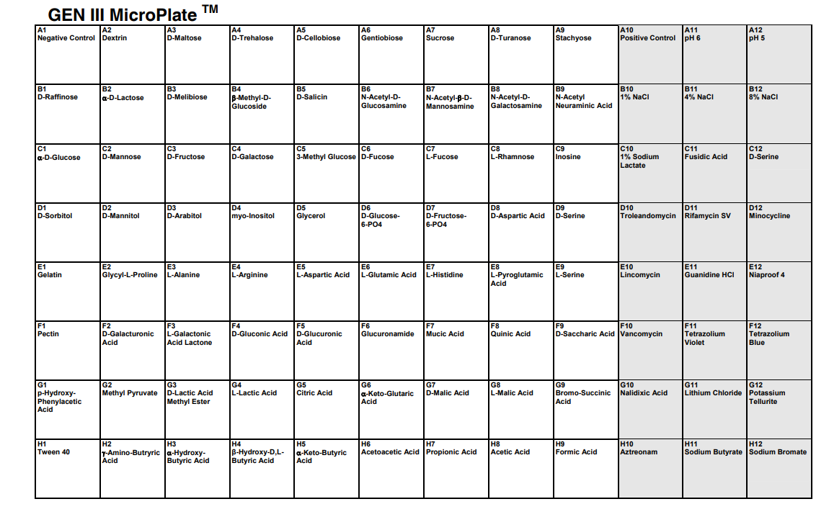
Figure 4.1: Biolog GEN III plate layout with carbon-source and control wells.

4.8 Procedures

4.8.1 Lab Safety

4.8.1.1 Before Lab
- Wear lab coat, goggles, and gloves.
- Wipe benches and pipettors with 70% ethanol.

4.8.1.2 During Lab
- Treat all tips as biohazards.
- Remove PPE when leaving the lab.
- Use personal devices as little as possible.

4.8.1.3 After Lab
- Clean work areas and personal items with ethanol.
- Dispose of liquids, plates, gloves, and glass using the assigned workflow.
- Return reusable materials and wash hands.

4.8.2 Methods: Activity 1, Turbidimeter
- Blank the turbidimeter with uninoculated IF-A fluid.
- Swab bacteria from the BUG agar plate into IF-A inoculating fluid.
- Mix gently and measure turbidity.
- Adjust the inoculum to a target density of 95% transmittance.

4.8.3 Methods: Activity 2, Biolog Plate Preparation
Figure Figure 4.2 shows the multichannel loading pattern used to inoculate each column consistently.
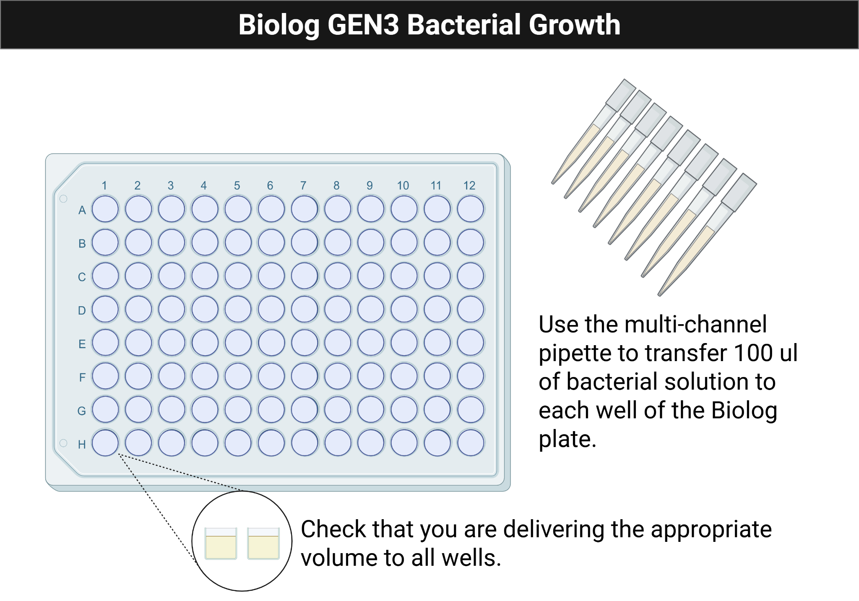
Figure 4.2: Loading a Biolog GEN III plate with a multichannel pipette.
Figure Figure 4.3 shows the expected appearance of an inoculated Biolog plate after incubation.
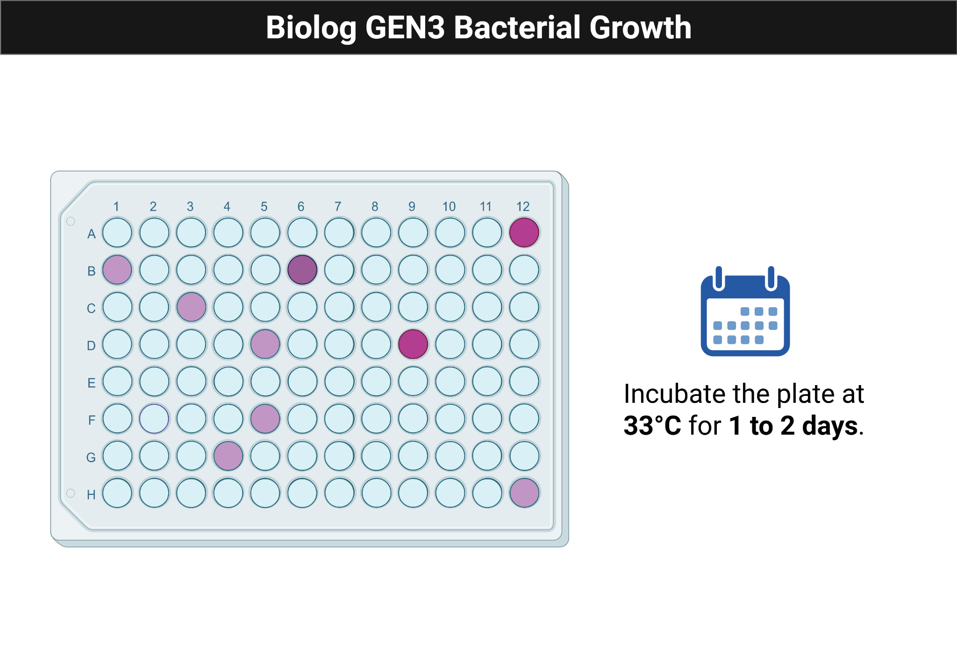
Figure 4.3: Biolog GEN III plate after incubation with visible growth response.
- Pour the prepared cell suspension into a multichannel reservoir.
- Load the multichannel pipette and add 100 µL to each well of the GEN III plate.
- Replace tips whenever contamination is possible.
- Confirm that every well contains liquid.
- Incubate one plate in the plate reader and another statically at 33 C for 1 to 2 days.

4.8.4 Protocol Notes
Record any mistakes, deviations, or strain-specific observations.

4.9 Results

4.9.1 Growth Curves
- Save and share the raw 600 nm readings.
- Export the blank-corrected table as CSV.
- Validate the data structure, convert time to minutes, and plot growth curves.

4.10 Result Analysis
Interpret color changes, growth patterns, and wells with or without growth. Identify which carbon sources appear supportive and which conditions inhibited the isolate.

4.11 Discussion Questions
- What are the advantages and disadvantages of using a multichannel pipette?
- How do you maintain a pure culture during inoculation, and why is that necessary here?
- What does a turbidimeter measure, and why is that important for this assay?
- Why are BUG-grown bacteria used instead of TSA-grown bacteria?
- How has your multichannel technique changed over the semester?

5. Module 5: Microbial Interactions

5.1 Overview
Weeks 8 and 9 focus on co-culture experiments that examine how isolates interact through diffusion-mediated contact.

5.2 Purpose
- Evaluate microbial interactions through co-culture growth of different isolates.
- Observe growth while maintaining fluidic contact across a membrane.
- Analyze possible inhibition or facilitation patterns.
- Use pipettes to seed co-culture wells for growth assays.
- Apply the principles of the Cerillo Duet system to your research question.

5.3 Learning Outcomes
- List safety considerations for propagating microbes.
- Explain the purpose of Duet wells and co-culture assays.
- Discuss the significance of microbial fluid interactions.
- Practice diluting cultures to a target value.
- Seed wells consistently without contamination.
- Describe the purpose, methods, and preliminary results of co-culture experiments.
- Collect and interpret co-culture growth data.
- Revise the draft for the individual and group projects.
- Explain how the experiment contributes to the overall research goal.

5.4 Skills and Knowledge

5.4.1 Skills
- Follow lab safety and PPE protocols.
- Use Cerillo vertical membrane co-culture systems correctly.
- Analyze co-culture growth data.

5.4.2 Knowledge
- PPE requirements for microbial work.
- Co-culture design and growth assessment.
- Microbial interaction concepts.

5.5 Task
Review the background and procedure information before lab and work with your partner to set up the co-culture assays and document results.

5.6 Criteria for Success
Successful completion requires participation in assay setup, collection of analyzable data, and a complete ELN record.

5.7 Background
After characterizing individual growth and metabolism, this module asks how isolates behave in the presence of other organisms. The Cerillo Duet co-culture platform allows isolates to grow in adjacent chambers separated by a membrane that permits exchange of metabolites without direct mixing of cells.

5.8 Procedures

5.8.1 Lab Safety
- Wear required PPE and clean benches and pipettors with 70% ethanol.
- Treat all tips as biohazards.
- Decontaminate liquids, glass, and work surfaces after lab.

5.8.2 Methods

5.8.2.1 What Was Prepared in Advance
- Overnight cultures of each isolate were started in 2.5 mL TSB and incubated at 30 C with shaking.

5.8.2.2 Day of the Lab
Figure Figure 5.1 maps the isolate-only, control, and co-culture conditions across the Cerillo Duet platform.
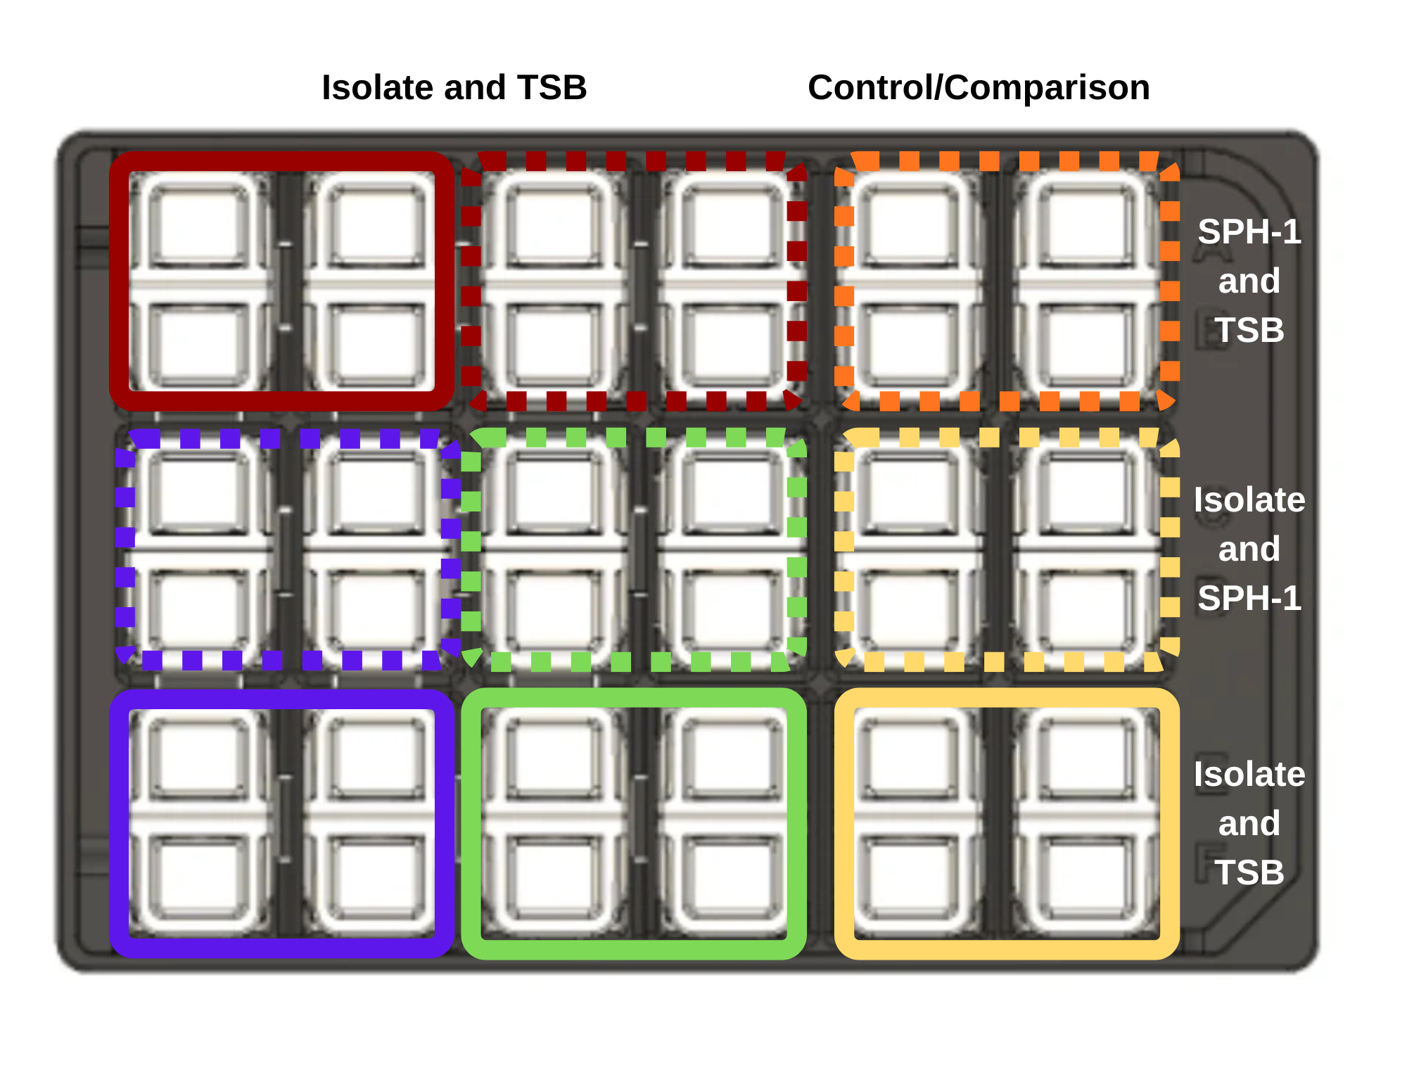
Figure 5.1: Cerillo Duet co-culture layout with isolate-only, control, and co-culture conditions.
- Dilute the overnight culture 1:1000 into fresh TSB.
- Add 800 µL of diluted culture to triplicate wells for the isolate-only condition.
- Add 800 µL of TSB to the adjacent control wells.
- Add 800 µL of diluted SPH-1 to the paired experimental wells for co-culture.
- Seal the plate carefully.
- Incubate with shaking at 30 C for 24 to 48 hours.
- Analyze OD600 measurements collected every 5 minutes.

5.8.3 Protocol Notes
Record any mistakes, deviations, or strain-specific observations.

5.9 Results
Add images of the co-culture plate and any figures generated from the growth data.

5.10 Result Analysis
Compare isolate-only growth to co-culture growth. Explain whether the second organism appeared to support, suppress, or otherwise reshape your isolate’s growth profile.

5.11 Discussion Questions
- How can co-culture systems help researchers understand microbial behavior?
- What kinds of metabolites or resources might explain improved or reduced growth in co-culture?

6. Module 6: Microbial Genome Sequencing

6.1 Overview
Weeks 11 and 12 focus on DNA isolation, quantification, sequencing preparation, and early genome analysis.

6.2 Purpose
- Evaluate DNA sequencing results and microbial genome assemblies.
- Follow a standard DNA isolation protocol.
- Apply bioinformatics tools to assemble microbial genomes and analyze predicted coding sequences.

6.3 Learning Outcomes
- List safety considerations for extracting DNA from microbial isolates.
- Explain the purpose of reagents used for DNA extraction.
- Discuss the significance of high-molecular-weight DNA for sequencing.
- Practice extracting DNA from liquid cultures.
- Practice quantifying DNA with a Qubit fluorometer.
- Describe the purpose, methods, and preliminary results of DNA extraction, quantification, and sequencing experiments.
- Collect and interpret DNA quantification and sequencing data.
- Revise the draft for the individual and group projects.
- Explain how the experiment contributes to the overall research goal.

6.4 Skills and Knowledge

6.4.1 Skills
- Follow lab safety and PPE procedures.
- Extract and quantify microbial DNA.
- Analyze microbial DNA sequence data.

6.4.2 Knowledge
- PPE requirements for DNA isolation and purification.
- DNA extraction and quantification methods.
- Oxford Nanopore Technologies sequencing workflows.

6.5 Task
Review the protocol before lab and work with your partner to isolate DNA from overnight cultures in duplicate, record all steps, and document the results.

6.6 Criteria for Success
Successful completion requires participation in DNA isolation and sequencing preparation, collection of analyzable data, and a complete ELN entry.

6.7 Background
This module connects phenotype to genotype by sequencing the genome of the isolate. DNA is extracted using the NO-MISS workflow and analyzed with Oxford Nanopore sequencing and downstream genome analysis tools such as BV-BRC and SeqHub.
Figure Figure 6.1 summarizes the sequencing and downstream analysis pipeline from isolate DNA to annotated genome.
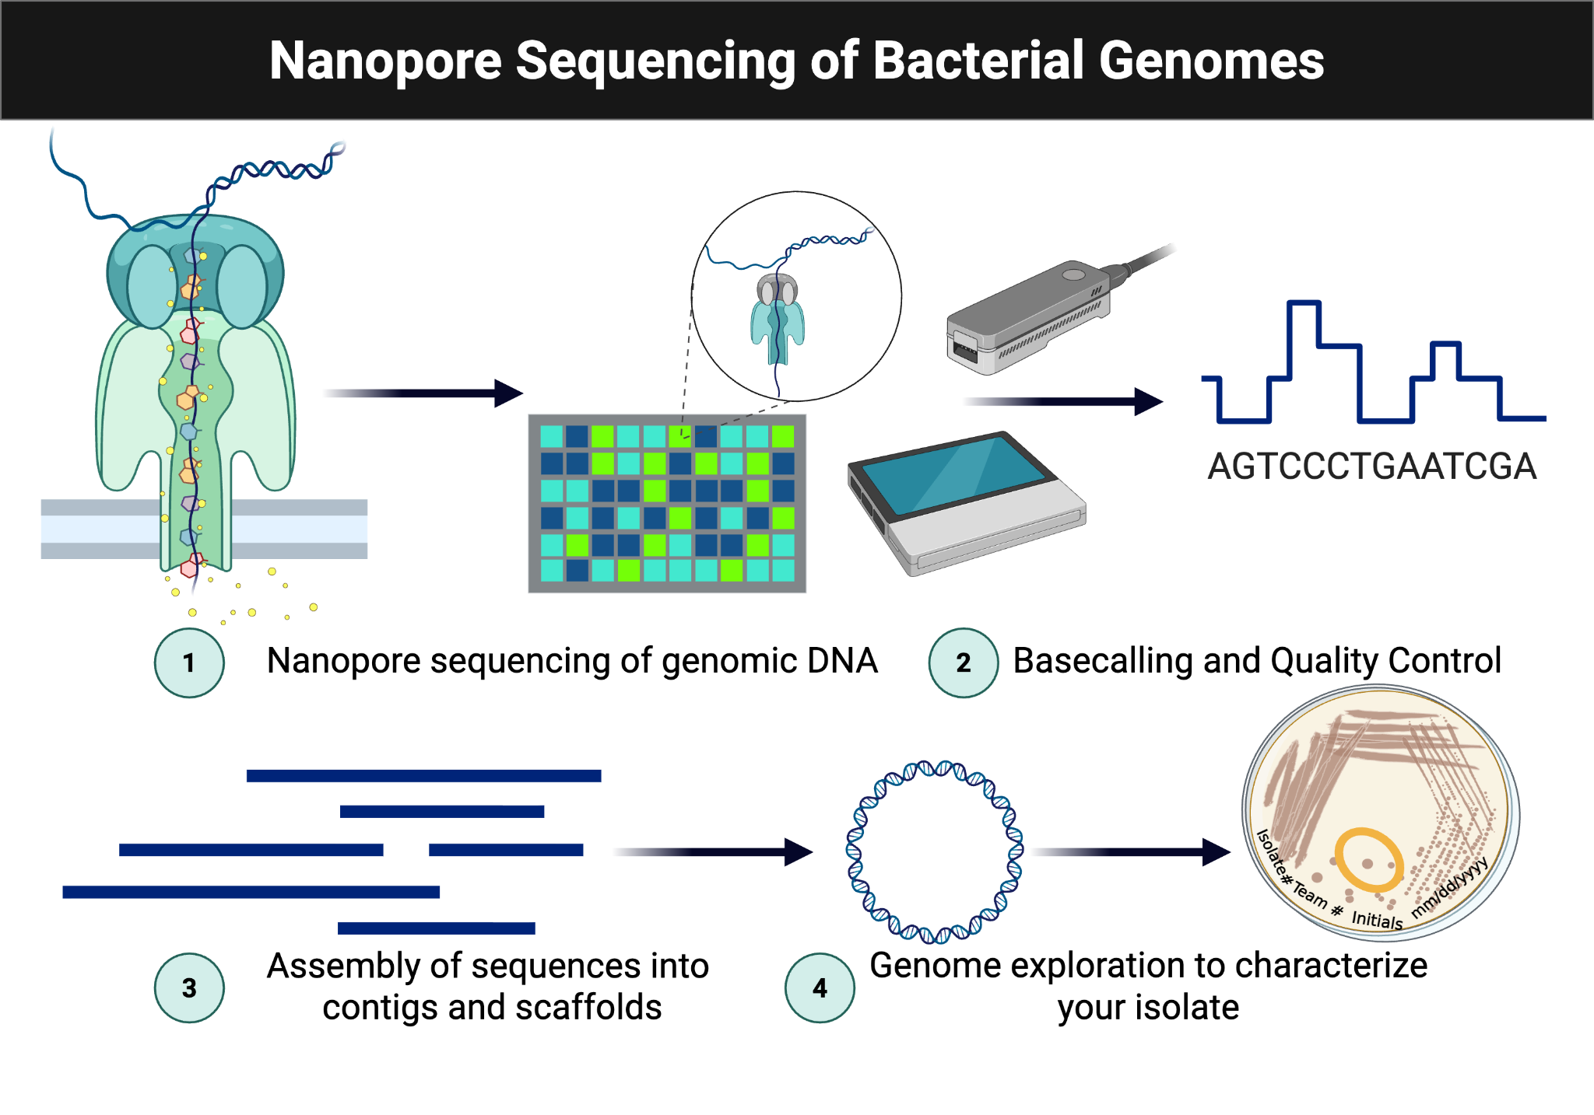
Figure 6.1: Nanopore sequencing and downstream analysis workflow.

6.8 Procedures

6.8.1 Lab Safety
- Wear lab coat, goggles, and gloves.
- Clean benches and pipettors with 70% ethanol.
- Treat all culture-associated materials as biohazards.
- Decontaminate liquids, plates, and work areas at the end of the session.

6.8.2 Methods

6.8.2.1 What Was Prepared in Advance
- Overnight cultures were started in TSB.
- Lysozyme was prepared in TE buffer at 10 mg/mL.

6.8.2.2 Day of the Lab
- Pellet 1.0 mL of culture in a DNA LoBind tube.
- Resuspend in TE buffer with lysozyme.
- Add Proteinase K and RNase A.
- Add CTAB buffer and incubate at 56 C for 30 minutes.
- Combine lysate with Monarch gDNA Binding Buffer at a 2:1 ratio.
- Bind DNA to the spin column, wash twice, and elute with preheated Monarch gDNA Elution Buffer.
- Quantify 1 µL of DNA with the Qubit fluorometer.
- Prepare sequencing-ready DNA according to the NO-MISS rapid barcoding workflow.
Figure Figure 6.2 illustrates the Qubit measurement setup used to quantify extracted DNA prior to library preparation.
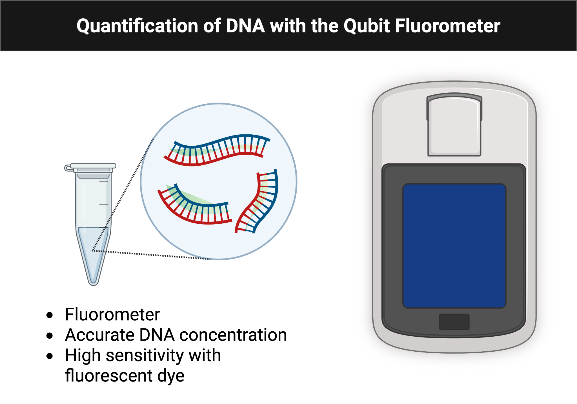
Figure 6.2: Qubit fluorometer workflow for DNA quantification.
Figure Figure 6.3 summarizes the rapid barcoding library-preparation workflow used before sequencing.
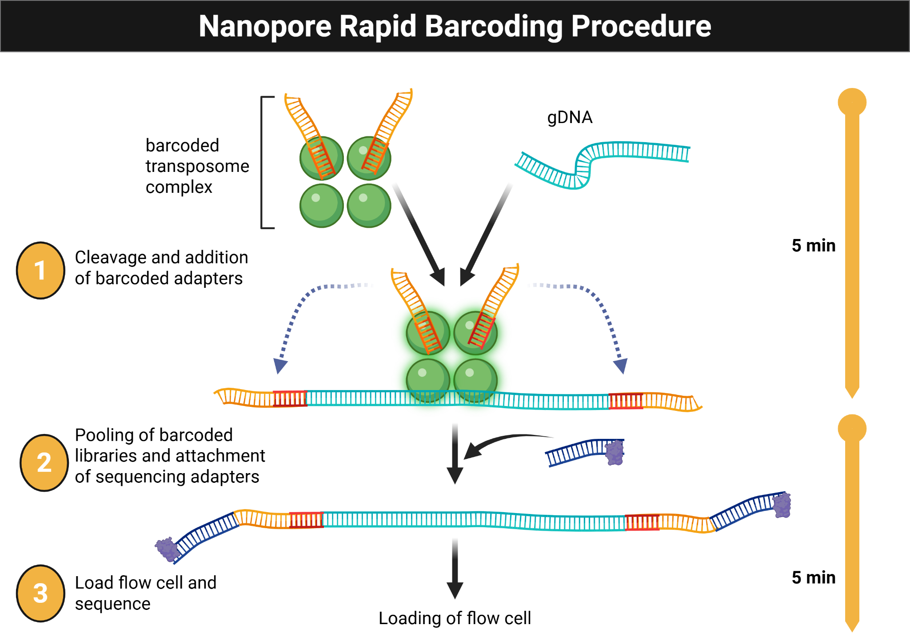
Figure 6.3: Nanopore rapid barcoding workflow for sequencing library preparation.

6.8.3 Data Analysis
- Create a BV-BRC account and access the shared workspace.
- Obtain the Nanopore and Illumina files for your isolate.
- Run the Comprehensive Genome Analysis workflow.
- Upload the assembled FASTA file to SeqHub for annotation and exploration.

6.8.4 Protocol Notes
Record any mistakes, deviations, or strain-specific observations.

6.9 Results
Add figures, screenshots, concentration values, and any sequencing outputs generated from your data.

6.10 Result Analysis
Discuss DNA yield, sample quality, and whether the sequencing-related results matched expectations. Include factors that may have affected DNA recovery and what you would change next time.

6.11 Discussion Questions
- How do microbial genome assembly and annotation tools support research?
- What makes nanopore sequencing different from other sequencing approaches?

7. Module 7: Data Analysis and Experimental Design

7.1 Overview
Weeks 13 and 14 focus on genome assembly, annotation review, comparative analysis, and connecting genomic results back to phenotype.

7.2 Purpose
- Evaluate DNA sequencing results and microbial genome assemblies.
- Submit an assembly job to BV-BRC.
- Apply bioinformatics tools to assemble genomes and analyze predicted coding sequences.

7.3 Learning Outcomes
- Explain the purpose of the bioinformatics tools and workflows used.
- Discuss the significance of genome assembly.
- Practice using web-based bioinformatics tools.
- Explore genome assemblies and annotations.
- Describe the workflow for microbial genome assembly.
- Collect and interpret genomic data in the context of phenotypic analyses.
- Revise the draft for the individual and group projects.
- Explain how this work contributes to the overall experimental goal.

7.4 Skills and Knowledge

7.4.1 Skills
- Perform sequence-read quality review.
- Assemble microbial genomes.
- Annotate and explore genome content.

7.4.2 Knowledge
- Steps required to assemble a microbial genome.
- Tools for filtering, assembly, annotation, and metabolic modeling.
- Cloud-based bioinformatics workflow submission.

7.5 Task
Work in pairs to obtain, explore, and interpret genome data and then connect those results to the phenotypic evidence collected earlier in the course.

7.6 Criteria for Success
Successful completion requires use of BV-BRC and SeqHub, careful documentation of outputs, and a complete ELN entry.

7.7 Background
Students now use sequence data generated earlier in the course to compare isolates with Delftia acidovorans SPH-1 and other related genomes. The goal is to identify genetic features that explain observed growth and metabolic behavior.
Figure Figure 7.1 is reused from the sequencing workflow to anchor where assembly, annotation, and comparative analysis fit into the broader pipeline.
Figure 7.1: Sequencing-analysis pipeline reused for genome assembly and comparative interpretation.

7.8 Procedures

7.8.1 Lab Safety
This is a bioinformatics lab.

7.8.2 Methods: Data Analysis
- Access the shared BV-BRC workspace.
- Obtain the concatenated read files for your isolate.
- Run the Comprehensive Genome Analysis workflow with long-read and paired short-read data.
- Create an output folder labeled with the isolate name.
- Submit the job and monitor the results.
- Upload the assembled FASTA file to SeqHub.

7.8.3 Methods: Genome Comparisons
- Use Similar Genome Finder in BV-BRC.
- Compare your isolate against representative and public genomes.
- Save the result tables and pie-chart images.
- Use the Genome Alignment workflow for follow-up comparisons.

7.8.4 Methods: Annotation Review and Genome Exploration
- Review coding-sequence counts and other reported features.
- Record the most abundant functional assignments.
- Note whether plasmids or antibiotic-resistance genes were identified.
- Explore low-confidence annotations, hypothetical genes, predicted protein interactions, and genes of interest in SeqHub.

7.8.5 Protocol Notes
Record any mistakes, deviations, or isolate-specific observations.

7.9 Results
Include tables, figures, charts, and screenshots generated from your assembly and annotation workflows.

7.10 Result Analysis
Explain how your isolate differs from the SPH-1 reference, how well the genomic data matches the phenotype, and what the assembly metrics suggest about data quality.

7.11 Discussion Questions
- How did BV-BRC assemble your genome, and how good was the assembly?
- What factors affect genome assembly quality?
- What applications beyond research rely on gene prediction and annotation?
- What can predicted protein interaction networks contribute to your project?

8. Module 8: Share Your Results

8.1 Overview
Week 15 is the capstone module. Students design or repeat an experiment, analyze the results, and connect the final experiment back to the semester’s genomic and phenotypic findings.
Figure Figure 8.1 provides a compact visual divider for the capstone week and surfaces the final remaining template image from the source document.
Figure 8.1: Capstone module banner carried over from the original workbook template.

8.2 Purpose
- Identify a focused research question for a specific bacterial strain.
- Construct an experimental procedure.
- Determine how to gather accurate and representative data.
- Analyze results in the context of the experimental design.

8.3 Experiment Goals
List at least two specific goals for your final experiment.
- [Add goal here]
- [Add goal here]

8.4 Learning Outcomes
- List safety considerations for working with microbial isolates.
- Review techniques, concepts, and experiments from the course.
- Repeat experiments to improve consistency and reproducibility.
- Describe the purpose, methods, and results of the experiment your team designs.
- Interpret genomic data, including gene annotations and protein interaction predictions.
- Revise the draft for the individual and group projects.
- Explain how the experiment contributes to the overall research goal.

8.5 Skills and Knowledge

8.5.1 Skills
Specify the lab skills your final experiment develops.
- [Add skill here]
- [Add skill here]

8.5.2 Knowledge
Specify the concepts, tools, and analysis techniques that this final experiment reinforces.
- [Add knowledge area here]
- [Add knowledge area here]

8.6 Task
Review the background and procedure information you have written before coming to lab. Work with your group to carry out the experiment, document all changes, and analyze the resulting data.

8.7 Criteria for Success
Successful completion requires full participation in the designed experiment, careful documentation, and a complete ELN entry with results and reflection.

8.8 Background
Write a short paragraph describing your strain, the experiment your team will perform, the science behind it, and how the experiment supports your final research goal.
[Add background here]

8.9 Procedures

8.9.1 Lab Safety

8.9.1.1 Before Lab
- Wear lab coat, goggles, and gloves.
- Wipe the bench and pipettors with 70% ethanol.

8.9.1.2 During Lab
- Treat all tips as potential biohazards.
- Remove PPE when leaving the lab.
- Discard samples and disposables correctly.
- Minimize use of personal devices.

8.9.1.3 After Lab
- Wipe the station and any touched personal items with 70% ethanol.
- Dispose of gloves, plates, liquids, and glass in the correct locations.
- Return reusable materials, remove PPE, and wash your hands.

8.9.2 Methods
Write your methods so another group could reproduce the experiment, including setup, controls, measurements, and the data-analysis plan.
[Add methods here]

8.9.3 Protocol Notes
Record any changes, mistakes, or isolate-specific variables during the experiment.

8.10 Results
Summarize what happened and include figures, tables, or photos as needed.
[Add results here]

8.11 Result Analysis
Explain what the results mean and whether they matched expectations.
[Add analysis here]

8.12 Discussion Questions
- What did you learn from exploring your genome assembly and annotation with BV-BRC and SeqHub?
- Were you able to conduct and repeat your proposed experiment at least once? Why or why not?
- What findings did you obtain, and what are their implications?
- What experiment would you do next, and why?

9. Appendix A: Supplies and Reagents
This appendix provides a consolidated checklist of supplies and reagents used across Modules 1 through 8.
Download: PDF | Word

9.1 Core Supplies and Equipment
- Disposable lab coats, nitrile gloves, and safety goggles
- Benchtop disinfectant (70% ethanol)
- Micropipettes (single channel and multichannel)
- Sterile pipette tips (appropriate volumes, preferably filtered)
- Sterile reservoirs for multichannel loading
- Sterile microcentrifuge tubes and culture tubes
- DNA LoBind 1.5 ml microfuge tubes (Eppendorf)
- Centrifuge and microcentrifuge
- Vortex mixer
- Shaking incubator for 30°C and 33°C incubation
- Incubator for 30-33°C static cultures and plates
- 96-well microplates
- Breathe-Easy breathable plate seals
- Peg-lid biofilm assay plates
- Cerillo Duet co-culture plate system
- Plate reader (OD600 kinetic and endpoint absorbance)
- Invitrogen Qubit fluorometer and assay tubes
- Invitrogen Qubit dsDNA HS Assay Kit
- Turbidimeter (Biolog Turbidimeter or equivalent)
- Sterile loops for colony transfer
- Biohazard waste containers

9.2 Microbiology Media and Biological Materials
- Delftia acidovorans isolates and comparison isolates
- Tryptic Soy Agar (TSA) plates (Teknova or Hardy Diagnostics))
- Tryptic Soy Broth (TSB) for liquid cultures (Teknova or Hardy Diagnostics)
- Biolog Blood Universal Growth (BUG) agar
- Biolog GEN III Microplates
- Biolog IF-A inoculating fluid (for Biolog GEN III assays)
- Phosphate-buffered saline (PBS)

9.3 Reagents for Pipetting and Assay Setup
- MiniPCR micropipetting cards
- Crystal violet solution (serial dilution activity)
- Dyed water solutions (blue, yellow, red food coloring) for volume challenge
- Dojindo biofilm viability detection reagent components:
  - WST solution
  - Electron mediator reagent
  - TSB diluent

9.4 DNA Extraction and Sequencing Reagents
- TE buffer (Ambion)
- Sigma Lysozyme (10 mg/mL in TE; powder form stored at -80°C)
- New England Biolabs (NEB) Monarch Proteinase K
- New England Biolabs (NEB) Monarch RNase A
- CTAB buffer (Promega)
- New England Biolabs (NEB) Monarch gDNA Binding Buffer
- New England Biolabs (NEB) Monarch wash buffers
- New England Biolabs (NEB) Monarch gDNA Elution Buffer
- Oxford Nanopore Technologies (ONT) Rapid Barcoding Kit (SQK-RBK114.24)reagents
- ONT Flow Cells (FLO-MIN114) and associated reagents for sequencing runs

9.5 Computational and Data Resources
- Electronic lab notebook (ELN)
- Quarto for workbook rendering
- BV-BRC.org account and workspace for assembly and annotation workflows
- SeqHub.org for genome exploration

9.6 Notes
- Prepare all sterile materials in advance and confirm lot numbers where required.
- Record any reagent substitutions, concentration changes, or protocol deviations in the ELN.
- Follow institutional biosafety and chemical safety policies at all times.

References

10. Carlos C. Goller
Carlos C. Goller is a Teaching Professor at North Carolina State University in Raleigh, NC. He teaches microbiology, life science, public health, and other fun courses as part of the Department of Biological Sciences. When not playing with Delftia acidovorans or code, Carlos enjoys spending time with his family and playing with his dog Sunshine.

10.1 Education

10.1.1 North Carolina State University
Raleigh, NC
Advisor: Dr. Sue Carson
Topic: Biotechnology Education and Curriculum Development

10.1.2 Duke University Medical Center
Durham, NC
Advisor: Patrick C. Seed
Topic: Bacterial Pathogenesis and Anti-infective Screening
The Hartwell Foundation Postdoctoral Fellowship
September 2008 - July 2012

10.1.3 Emory University
Atlanta, GA
Advisor: Tony Romeo
Topic: Bacterial Biofilm Formation and Regulation
Ph.D. in Microbiology and Molecular Genetics
August 2002 - September 2008

10.1.4 Worcester Polytechnic Institute
Worcester, MA
B.S. in Biology and Biotechnology
August 1998 - May 2002

10.2 Experience
- Teaching Professor, North Carolina State University Department of Biological Sciences, 2024 - Present
- Associate Teaching Professor, North Carolina State University Department of Biological Sciences, 2019 - 2024
- Assistant Teaching Professor, North Carolina State University Department of Biological Sciences, 2015 - 2019

10.3 Additional Links
- BSC 495: The Hidden World’s Code
- GitHub Profile
- LinkedIn Profile

11. Camila Loyola
Camila Loyola is a Graduate Teaching Assistant in MB 360 and a student in the Master of Microbial Biotechnology program at North Carolina State University.
She supports student learning across the workflow from foundational lab practice to data analysis and experimental design in microbial metabolism and genomics.

11.1 Program
Master of Microbial Biotechnology
North Carolina State University

11.2 Role in MB 360
- Graduate Teaching Assistant
- Supports laboratory instruction and student mentoring
- Contributes to workbook implementation and module delivery

Figures
This page provides a quick index to the figures embedded throughout the workbook.

About
- Author profile for Dr. Carlos C. Goller in About
- Author profile for Camila Loyola in About Camila Loyola

Module 1
- Figure Figure 1.1 in Module 1: Micropipette volume display
- Figure Figure 1.2 in Module 1: Serial dilution overview
- Figure Figure 1.3 in Module 1: Top rows of a 96-well microplate
- Figure Figure 1.4 in Module 1: blank 96-well plate template

Module 2
- Figure Figure 2.1 in Module 2: Single-colony transfer for streaking

Module 3
- Figure Figure 3.1 in Module 3: Growth-curve plate layout
- Figure Figure 3.2 in Module 3: Biofilm viability workflow

Module 4
- Figure Figure 4.1 in Module 4: Biolog GEN III layout
- Figure Figure 4.2 in Module 4: Multichannel loading of the Biolog plate
- Figure Figure 4.3 in Module 4: Biolog plate after incubation

Module 5
- Figure Figure 5.1 in Module 5: Cerillo Duet co-culture plate layout

Module 6
- Figure Figure 6.1 in Module 6: Nanopore sequencing and downstream analysis workflow
- Figure Figure 6.2 in Module 6: Qubit quantification workflow
- Figure Figure 6.3 in Module 6: Oxford Nanopore Technologies (ONT) rapid barcoding workflow

Module 7
- Figure Figure 7.1 in Module 7: Sequencing analysis pipeline

Module 8
- Figure Figure 8.1 in Module 8: Capstone module banner

